## Filter my favorite Indicators to optimize my probability for a successful trade

Do I wish to **buy**/go **long** and hope market raises **OR** do I wish to **sell/short** the asset if we expect the market to go down?

## User Indicator programming and backtesting

Basics understanding of an Indicator, it can only be in 2 states:

* **Active** – Indicator is signaling to **ENTER the market (long/short) or hold trade position.**
* **No signal** – Indicator is not signaling any direction or signaling to **EXIT an ongoing trade**.

With the basics known, the user can now define and program how he wants our application to calculate all the indicators to **ENTER**, **HOLD** and **EXIT** strategies in the steps below:

## Step 1 Select INDICATORS for strategy testing

A user selects his favorite indicators from our library, he can mix them freely from:

* **Technical indicator**
* **Price bars patterns indicator**
* **Chart patterns indicator**

## Step 2 Optimization and Signal selection - Open for GUI solutions/designs!

Once a user has his 1-10 indicators up on dashboard, he then proceeds to configure and program the simulation. He first select signal and optimization for each indicator:

* If the indicator have more than one method to indicate a buy or sell signal the user will select the one he is interested in. ***Otherwise there will be no signal option*** ***since there is only one***
* User can then select to optimize the parameters if it´s possible for that timeframe going back 1,3 6 months of historical data
* User can also manually select parameters for indicator.
* Save settings

## Step 3 Define ENTER signal

Once user have his 1-10 indicators up on dashboard he then proceeds to define which trades he is interested in:

* Buy/long **and** Sell/short signals (Default setting, meaning all trade signals available)
* Buy/long only signals. (Ignore sell/short signals)
* Sell/short only signals (Ignore buy/long signals)

## Step 4 Activation or HOLD position period

Once the indicator has made a ENTER signal the user now defines the conditions for **each** Indicator to hold an Active state or position.

* Indicator Active until indicator switch to opposite buy/sell signal (Default setting)
* Indicator Active until the indicator change direction
* Indicator active until certain price change in percent or value.*
* Indicator active during x amount of price bars or time in minutes*

**\*IMPORTANT** Exit signal will be when we hit Price or Time target **or** Exit parameters in **Part 6** are meet, **whichever comes first!**

**Step 5 User programming, define attribute (Regular, Master or Slave) of indicators and ENTER the market when conditions are meet:**

1. **Regular** - Enter market when all **Regular** indicators are active and indicate same trade direction. (**Default setting**)
2. **Master**- Enter market if this indicator is active independent of all other **Regular/Slave** indicator statuses and directions.
3. **Slave** - Enter market if thisindicator and all other **Regular/Slave indicators** are active, Or Enter market if all other **Regular/Slave** indicators are active even if this indicator is not active

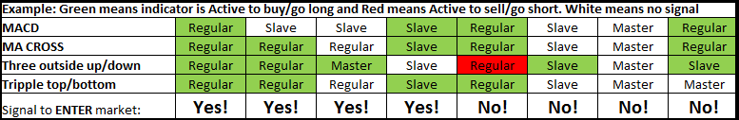

**Step 6 Programming, EXIT the market when all indicators are:**

1. **Regular** - Exit market when all **Regular** indicators are no longer active or has changed signal side, see last YES example where a buy/long position gets an EXIT signal because one indicator has already changed side to a sell/short active (***Default setting***)
2. **Master**- Exit market if this indicator is no longer active, independent of all other **Regular/Slave** indicator statuses.
3. **Slave** - Exit market if thisindicator and all other **Regular/Slave indicators** are not active or has changed signal side, Or Exit market if all other **Regular/Slave** indicators are no longer active even if this indicator is not active.

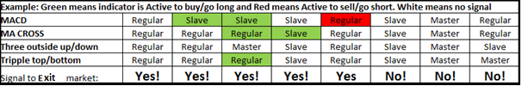

**Trading lab will of course calculate trading statistics one user has run its simulations:**

**Trading lab statistics:**

Best risk to reward Target +2.28% / Stop loss -1.29% *

Win/loss ratio: 63% (252 wins/148 loss)

Max losing streak: 9 losses in a row

Max winning streak: 8 wins in a row

Average time for buy signal: 15 bars (30 hours)

Average time for sell signal: 12 bars (24 hours)

Average profit: 2.12% (217 USD at current price)

Average loss: 1.82% (185 USD at current price)

*Best Risk to Reward will only calculate ENTER long/short signal trades established in Step 5, it does not consider any other strategy other than optimizing the profits taking from those historical ENTER signals! This is very important because that will indicate the RISK TO REWARD RATIO even before we ENTER the market based on historical data!!